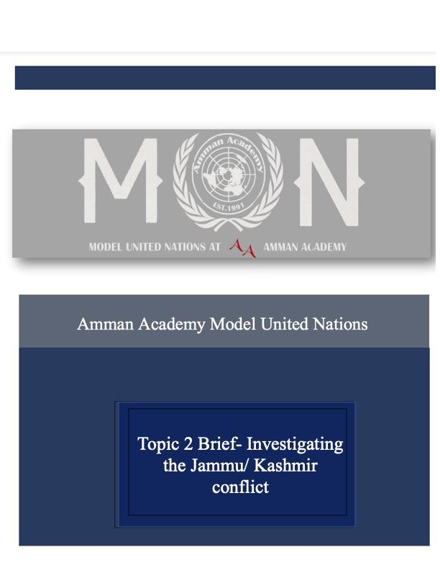 **Introduction:**

The Jammu/ Kashmir territory dispute is a conflict that originated back in 1947 when a disagreement over who ruled the land started rising when India and Pakistan both claimed the right to the Kashmir region and tensions rose when both parties couldn’t reach an agreement. China later joined as a third party to help find a solution, but it would later come to light that China was only in it to claim a part of the land. Each one these countries has a reason behind claiming the region. India claims the land of Kashmir because of the geographical location and it being closer to India than Pakistan, Pakistan Claims Kashmir as part of Pakistan due to the high Muslim percentage of citizens. While China only claims the small regions of the land that are close to it such as Shaksgam valley.

China is mostly supportive of Pakistan in this dispute and condemns India for claiming the region, but experts predict that even with the India making a move to claim Kashmir, economic and political ties wont be affected between India and China.

Even though a cease fire was ordered by the United Nations numerous times, neither country did stop, and three major wars broke out.

The first war to break out was in 1947 which was the result of Pakistani rebellions storming through the Kashmiri- Pakistani border, trying to claim Kashmir as part of Pakistan. This didn’t settle with Indian military located in Kashmir and they resorted to opening fire and this lead to 4 month war.

The second war to occur in Jammu/ Kashmir was in 1965 and lasted for almost a month with India coming out victorious.

The third war to break out in the region was in 1999 and it lasted for 3 months and resulted in India winning for the third time in a row and establishing dominance in the region.

**Why is this an issue:**

Ever since both Pakistan and India declared themselves as nuclear countries, “The United States has identified South Asia as an epicenter of terrorism and religious extremism and therefore has an interest in ensuring regional stability, preventing nuclear weapons proliferation, and minimizing the potential of a nuclear war between India and Pakistan.” (CFR, 2022).

The whole dispute over the land hasn’t only affected India and Pakistan, but South Asia as a whole since it affected the way the United States views them.

**The case in the Security Council:**

The dispute between India and Pakistan was first discussed in the UN in the Security Council in 1948 when India drafted the complaint to the UN in order to find a peaceful resolution to the disagreement they have been having for years. 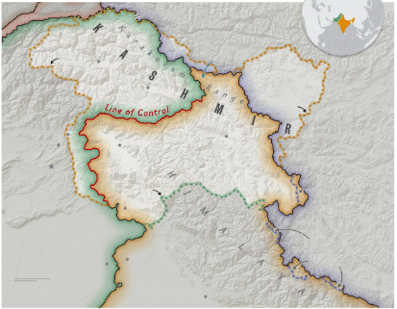

This issue is considered one of the

oldest issues in the UN and has been

under discussion in the Security

Council for over 70 years and it was one of the first

resolutions ever passed in the UN. The Security

Council decided that India’s claim that the Kashmir

region belonged to them was rejected. The case is still

ongoing until now and a resolution is yet to be found.

The opening of the topic in the UN means that all

parties involved had to sign a binding agreement to

maintain peace in the region, yet it had no effect

because 2 other wars have broken out in the region since then.

**Recent investigation advancements:**

Recent UN investigations have shown that India illegally announced Kashmir as part of its territory, and a letter from the Pakistani representative in the Security Council where he expresses the displacement of the Pakistani government and demands immediate action from the UN.

The second resolution that passed regarding this dispute, demanded an immediate ceasefire and that there is no delaying of the implementation of the resolution.

The government of India and the government of Pakistan have both signed an agreement for a ceasefire, and any present military personnel have 30 days to vacate the area.

**Timeline:**

|  |  |
| --- | --- |
| October 1947 | First Kashmir war begins. |
| January 1948 | The UN orders ceasefire, leaving part of Jammu and Kashmir on Pakistan side. |
| August 1949 | Administration of Kashmir is given to Pakistan by gilgit- balistatian administration. |
| May 1963 | Pakistan cedes trans karakoram tract, a part of Kashmir, to China. |
| February 1994 | India adopt resolution stating that Pakistan must vacate the region. |
| August 2019 | India says that any talks from now on will be held on parts of Kashmir only. |

**Resources:**

* <https://www.bbc.com/news/10537286>
* <https://www.nationalgeographic.com/culture/article/kashmir-conflict-how-did-it-start>
* <https://moderndiplomacy.eu/2022/11/14/any-solution-for-kashmir/>
* <https://www.dw.com/en/how-far-will-china-go-to-support-pakistans-position-on-kashmir/a-49993550>
* <https://www.livemint.com/politics/news/why-new-delhi-is-turning-up-the-heat-on-pok-now-1566324538622.html>
* <https://www.idsa.in/specialfeature/forgotten-fact-of-china-occupied-kashmir-srchinoy-131120>
* <https://www.outlookindia.com/national/the-history-of-kashmir-conflict-news-189840>
* <https://www.cfr.org/global-conflict-tracker/conflict/conflict-between-india-and-pakistan>
* <https://pakun.org/kashmir/history.php>
* <https://www.securitycouncilreport.org/un-documents/jammu-and-kashmir/>